RESPONSE QUESTION 1/2: Compare and contrast these two figures in a paragraph. You may want to think about naturalism, dress, scarification, etc…
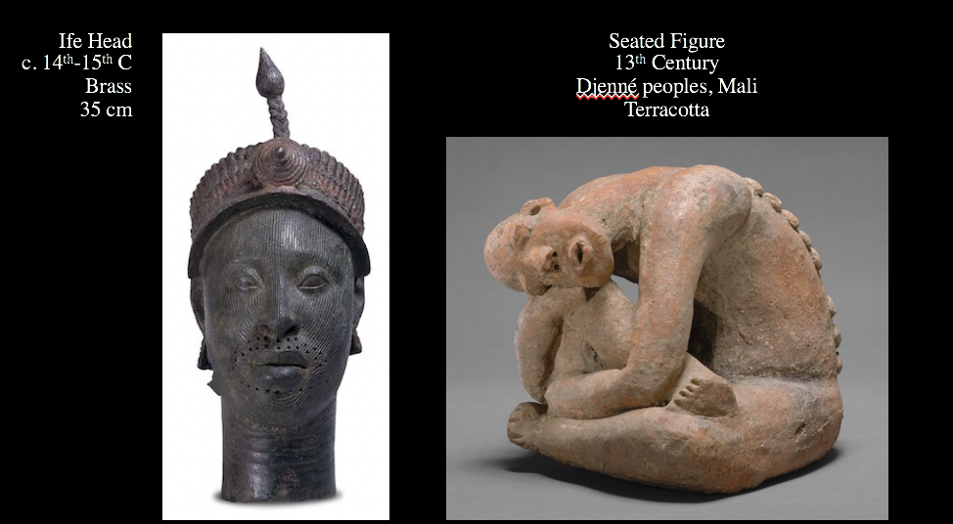

The Ife head is very naturalistic, while the Seated Figure is more abstracted, especially in the facial features and the pose. The Ife Head is so naturalistic that it seems individualized, especially in the slight curve of the eye brows and the shape of the nose. The face of the Seated Figure though does not seem like a specific person, and the attention is more on the pose than facial detailing. Both show scarification and so may have ritual connotations.

RESPONSE QUESTION 2/3: Describe this plaque in a paragraph.
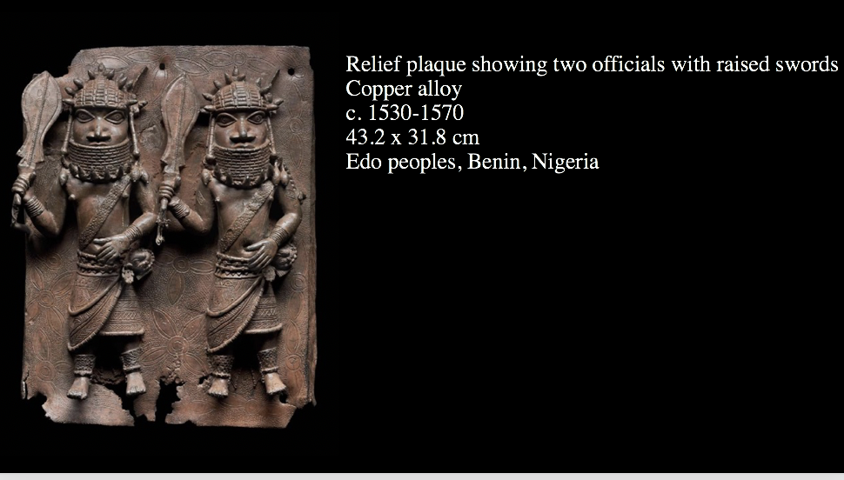

This plaque shows two abstracted figures. One is larger than the other, showing hierarchy of scale. This size differential also suggests depth; the larger figure seems closer to the viewer than the smaller one because their feet are not in a line. The smaller figure is not just shorter, but stands behind the larger figure. They have the exact same dress though, with stylized spiked headdresses and draping skirts, which suggests they may be of similar rank. In high relief, they protrude from the bronze as they raise their arms, swords in hand, creating movement in the composition.

Student Questions

Was Islam a religion that took place significantly in most parts of Africa during this time?
Islam was first introduced to the continent in the 7th century, so it has been significant there for a very long time. There are many variants of the religion, which was influenced by regional belief systems in Africa. Africa now has a very large Muslim population; about 40% of the people in Africa are Muslim.

Does the Great Mosque of Djenné Roof still serve as a functional place of worship?
Yes, it is still used as a mosque.

Are the ceramic half-pipes more effective than the weeper-holes used in the Ziggurat of Ur?
Good question; there isn’t a strict yes or no answer. The half-pipes direct rainfall away from the building, while the holes in the ziggurat allow for evaporation, so they are different ways of removing water, neither of which is 100% effective. The bitumen that encases the Ziggurat is a major factor in its preservation. The mosque doesn’t use bitumen. Neither would survive indefinitely without restoration.

Do the positive and negative spaces help with weight distribution? The Antelope headdresses look heavy. Does positive and negative space apply to sculptures as well (like design wise)?

Yes, the carving of the headdress helps balance the weight and lighten the headdress for the wearer. So in this case the negative space does help with weight distribution, but this is not part of the definition of negative space. For instance, the space between the legs of a sculpture in the round would be negative space, as would the space under a table. So, this function is not integral to the definition of positive versus negative space.

Regarding positive and negative space, those apply to paintings too right? I often use these terms to describe the background and the tiny spaces of some part of the same layer if you know what I mean but I’m not sure if I’m using the correct term regarding or correct way.
Negative and positive space refer to paintings as well. Negative space often refers to background areas. When this term is used it’s not describing background in terms of foreground and midground, but background in the more everyday use of the world. The positive space is the subject and the negative space is the empty area of the canvas (even if the canvas is painted). Imagine you have a canvas painted blue, on which someone has painted a person and a house. The house and the person are positive space. The blue would be negative space.

On slide 14, the antelope objects considered abstract or semi-abstract? They would have served to be headdresses given that they are supposed to resemble antelopes thus making them objective and not abstract. But to the naked eye, it doesn’t look otherwise. More like a crane with the long beaks.
These headdresses would be abstracted. Their function doesn’t have to do with whether or not their abstracted. Ask not whether they look like headdresses, but if they look like antelopes. They are abstracted depictions of antelopes while still being functional objects (headdresses).

